Fisheries Liaison and Coexistence Plan
Harrow Bay Offshore Wind
Tom Berger · 30 July 2026 · HB-STK-PLN-0002

1. Purpose
This plan sets out how Weyland works with the local fishing industry during the construction of Harrow Bay. It fulfils consent condition 7 and follows the FLOWW best-practice guidance for fisheries liaison with offshore wind.

2. Fishing activity in the area
The wind farm and the export cable corridor overlap with grounds used by around 40 inshore vessels from Harrow Bay, Eastholm and Saltwick, mainly potting for crab and lobster (inshore, KP 0–19) and some trawling for whitefish and Nephrops further offshore. Peak potting season is April to October.
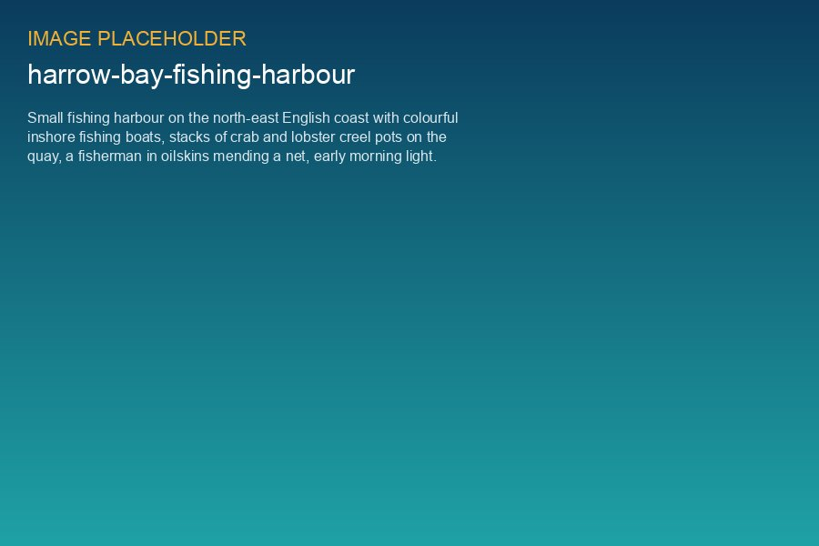
Harrow Bay harbour – the home port of most potting vessels in the cable corridor

3. Liaison arrangements
Role | Name | Contact
Fisheries Liaison Officer (FLO) | Grace Mitchell | +44 7700 900 745
Fishing industry representative | Harrow Bay & District Fishermen's Association | monthly meeting
Marine Coordination Centre | Ingrid Solberg | VHF 72 / +44 1632 960 455

4. Measures
- Weekly Notices to Mariners and a fortnightly Kingfisher bulletin
- Guard vessels from the local fleet (two vessels contracted for 2026)
- Gear relocation payments where pots must be moved from the cable corridor (rates agreed in March 2026)
- Burial depth increased to 2.0 m between KP 12 and KP 19 (CO-002) to allow trawling over the cable
- Claims procedure for gear damage – response within 10 working days

5. Disruption payments 2026
Item | Vessels | Amount (GBP)
Gear relocation – cable corridor survey (July) | 11 | 38,500
Guard vessel contracts (Apr–Oct) | 2 | 412,000
Gear damage claims settled | 3 | 6,240

